Movement ecology of vulnerable lowland tapirs across a gradient of human disturbance

MJ Noonan $​^{1}$, S Mezzini $​^{1}$, CH Fleming $​^{2,3}$, JM Calabrese $​^{4,5,6}$, EP Medici $​^{7*}$

1 – The Irving K. Barber Faculty of Science, The University of British Columbia, Okanagan Campus, 1177 Research Road, Kelowna, BC Canada V1V 1V7.

2 – University of Maryland College Park, College Park, MD, USA.

3 – Smithsonian Conservation Biology Institute, Front Royal, VA, USA.

4 – Center for Advanced Systems Understanding (CASUS), Görlitz, Germany.

5 – Helmholtz-Zentrum Dresden Rossendorf (HZDR), Dresden, Germany.

6 – Department of Ecological Modelling, Helmholtz Centre for Environmental Research (UFZ), Leipzig, Germany.

7 – Lowland Tapir Conservation Initiative, Instituto de Pesquisas Ecológicas (IPÊ), Rodovia Dom Pedro I, km 47, 12960-000, Nazaré Paulista, São Paulo, Brazil.

**\*Corresponding Author**: [medici@ipe.org.br](mailto:medici@ipe.org.br)

**Running head:** Lowland tapir space use

|  |  |  |
| --- | --- | --- |
|  |  |  |
|  |  |  |
| Words in the abstract: XX |  | Number of Figures: XX |
|  |  |  |
| Words in main text: XX |  | Number of tables: XX |
|  |  |  |
| Number of references: XX |  | Supplementary material: XX |

**Statement on human or animal subjects:** NEED PATI HERE

# 1 Abstract

**Keywords:**

# 2 Introduction

While agriculture, urbanisation, and transportation infrastructure are critical to human socio-economic improvement (Esfahani and Ramı́rez 2003), the associated habitat transformations represent a major threat to species survival (Fahrig 1997; Venter et al. 2006; Powers and Jetz 2019). Of particular concern is the impact of human activities on animal movement and space use (Allen and Singh 2016; Tucker et al. 2018; Doherty, Hays, and Driscoll 2021). Animal movement governs how individuals, populations, and species interact with each other and the environment (Schick et al. 2008; Martinez-Garcia et al. 2020; He et al. 2021) and mediates key ecological processes (Bauer and Hoye 2014). The capacity for individuals to move unhindered across complex landscapes is therefore critical for species survival and ecosystem function. Problematically, human development has been reducing the amount of habitat available to wildlife (Brooks et al. 2002; Cardinale et al. 2012; Hooper et al. 2012). This has spurred substantial changes in animal movement behaviour across the globe (Fahrig 2007; Tucker et al. 2018; Doherty, Hays, and Driscoll 2021), with potential consequences including reduced fitness and survival, altered predator-prey dynamics, reduced seed dispersal, genetic isolation and local extinction (Fahrig 2007; Dickie et al. 2017; Cosgrove, McWhorter, and Maron 2018; Tucker et al. 2021).

Notably, human disturbance has been shown to have differential effects across species (Toews, Juanes, and Burton 2018; Doherty, Hays, and Driscoll 2021), even for closely related taxa occupying the same habitat (Thatte et al. 2020). Responses to human activities are thus largely taxa and context specific (Doherty, Hays, and Driscoll 2021) and there are no clear *a priori* expectations as to how any given species might be expected to respond to human disturbance. For instance, although Wall et al. (2021) found a tendency for African elephants (*Loxodonta spp.*) to have reduced movement in human modified landscapes, Morato et al. (2016) noted that jaguars (*Panthera onca*) living in regions with high human population densities occupied home ranges that were orders of magnitude larger than those of jaguars living in more pristine habitats.

As human disturbance is only expected to worsen over the next decade it is critical to better understand how species respond to human disturbance in order to develop effective conservation strategies. To this end, here we focus on understanding how the movement behaviour of lowland tapirs (*Tapirus terrestris*, henceforth ‘tapirs’) varies across three biomes in southern Brazil, the Pantanal, Cerrado, and Atlantic Forest. Tapirs are herbivores of the order Perissodactyla that can reach over 2.5 meters and weigh up to 250kg (Myers et al. 2006) and are distributed throughout South America (Gardner 2008). Tapir populations have suffered severe reductions, with local and regional extirpations, and are currently classified as vulnerable to extinction (Varela et al. 2019). PATI THIS SECTION IS MOSTLY UP TO YOU AS NOT MUCH HAS BEEN PUBLISH ON LOWLAND TAPIR BIOLOGY/ECOLOGY. We use an extensive telemetry dataset collected over XX years to describe the movement ecology of tapirs and study how changes in human disturbance influence their movement and space use. Currently, almost nothing is known about the movement ecology of tapirs (but see C. H. Fleming et al. 2019). Because large herbivores tend to increase (Doherty, Hays, and Driscoll 2021) our underlying hypothesis was that tapirs should exhibit greater movement distances and larger home range areas when living in human-modified landscapes. Findings are directly applicable to developing management plans, not only for tapirs but possibly also to other medium-large herbivores throughout South America.

# 3 Methods

## 3.1 Study area and data collection

The data was collected in three different ecosystems in southern Brazil (Fig. 3.1): south-western Cerrado (savannah, control environment), Pantanal (wetland, agricultural environment), and western Mata Atlântica (forest, degraded environment).

*Add details on climate and land use?*

Animals were tracked using VHF tracking (all three regions) and GPS tracking (Pantanal and Cerrado). *Add details on capturing and tracking devices*

A total of 74 tapirs were tracked starting in July of 1997 until October of 2019, with the majority of the data being in the Pantanal (46), while 17 and 11 were from the Cerrado and Mata Atlântica regions, respectively.

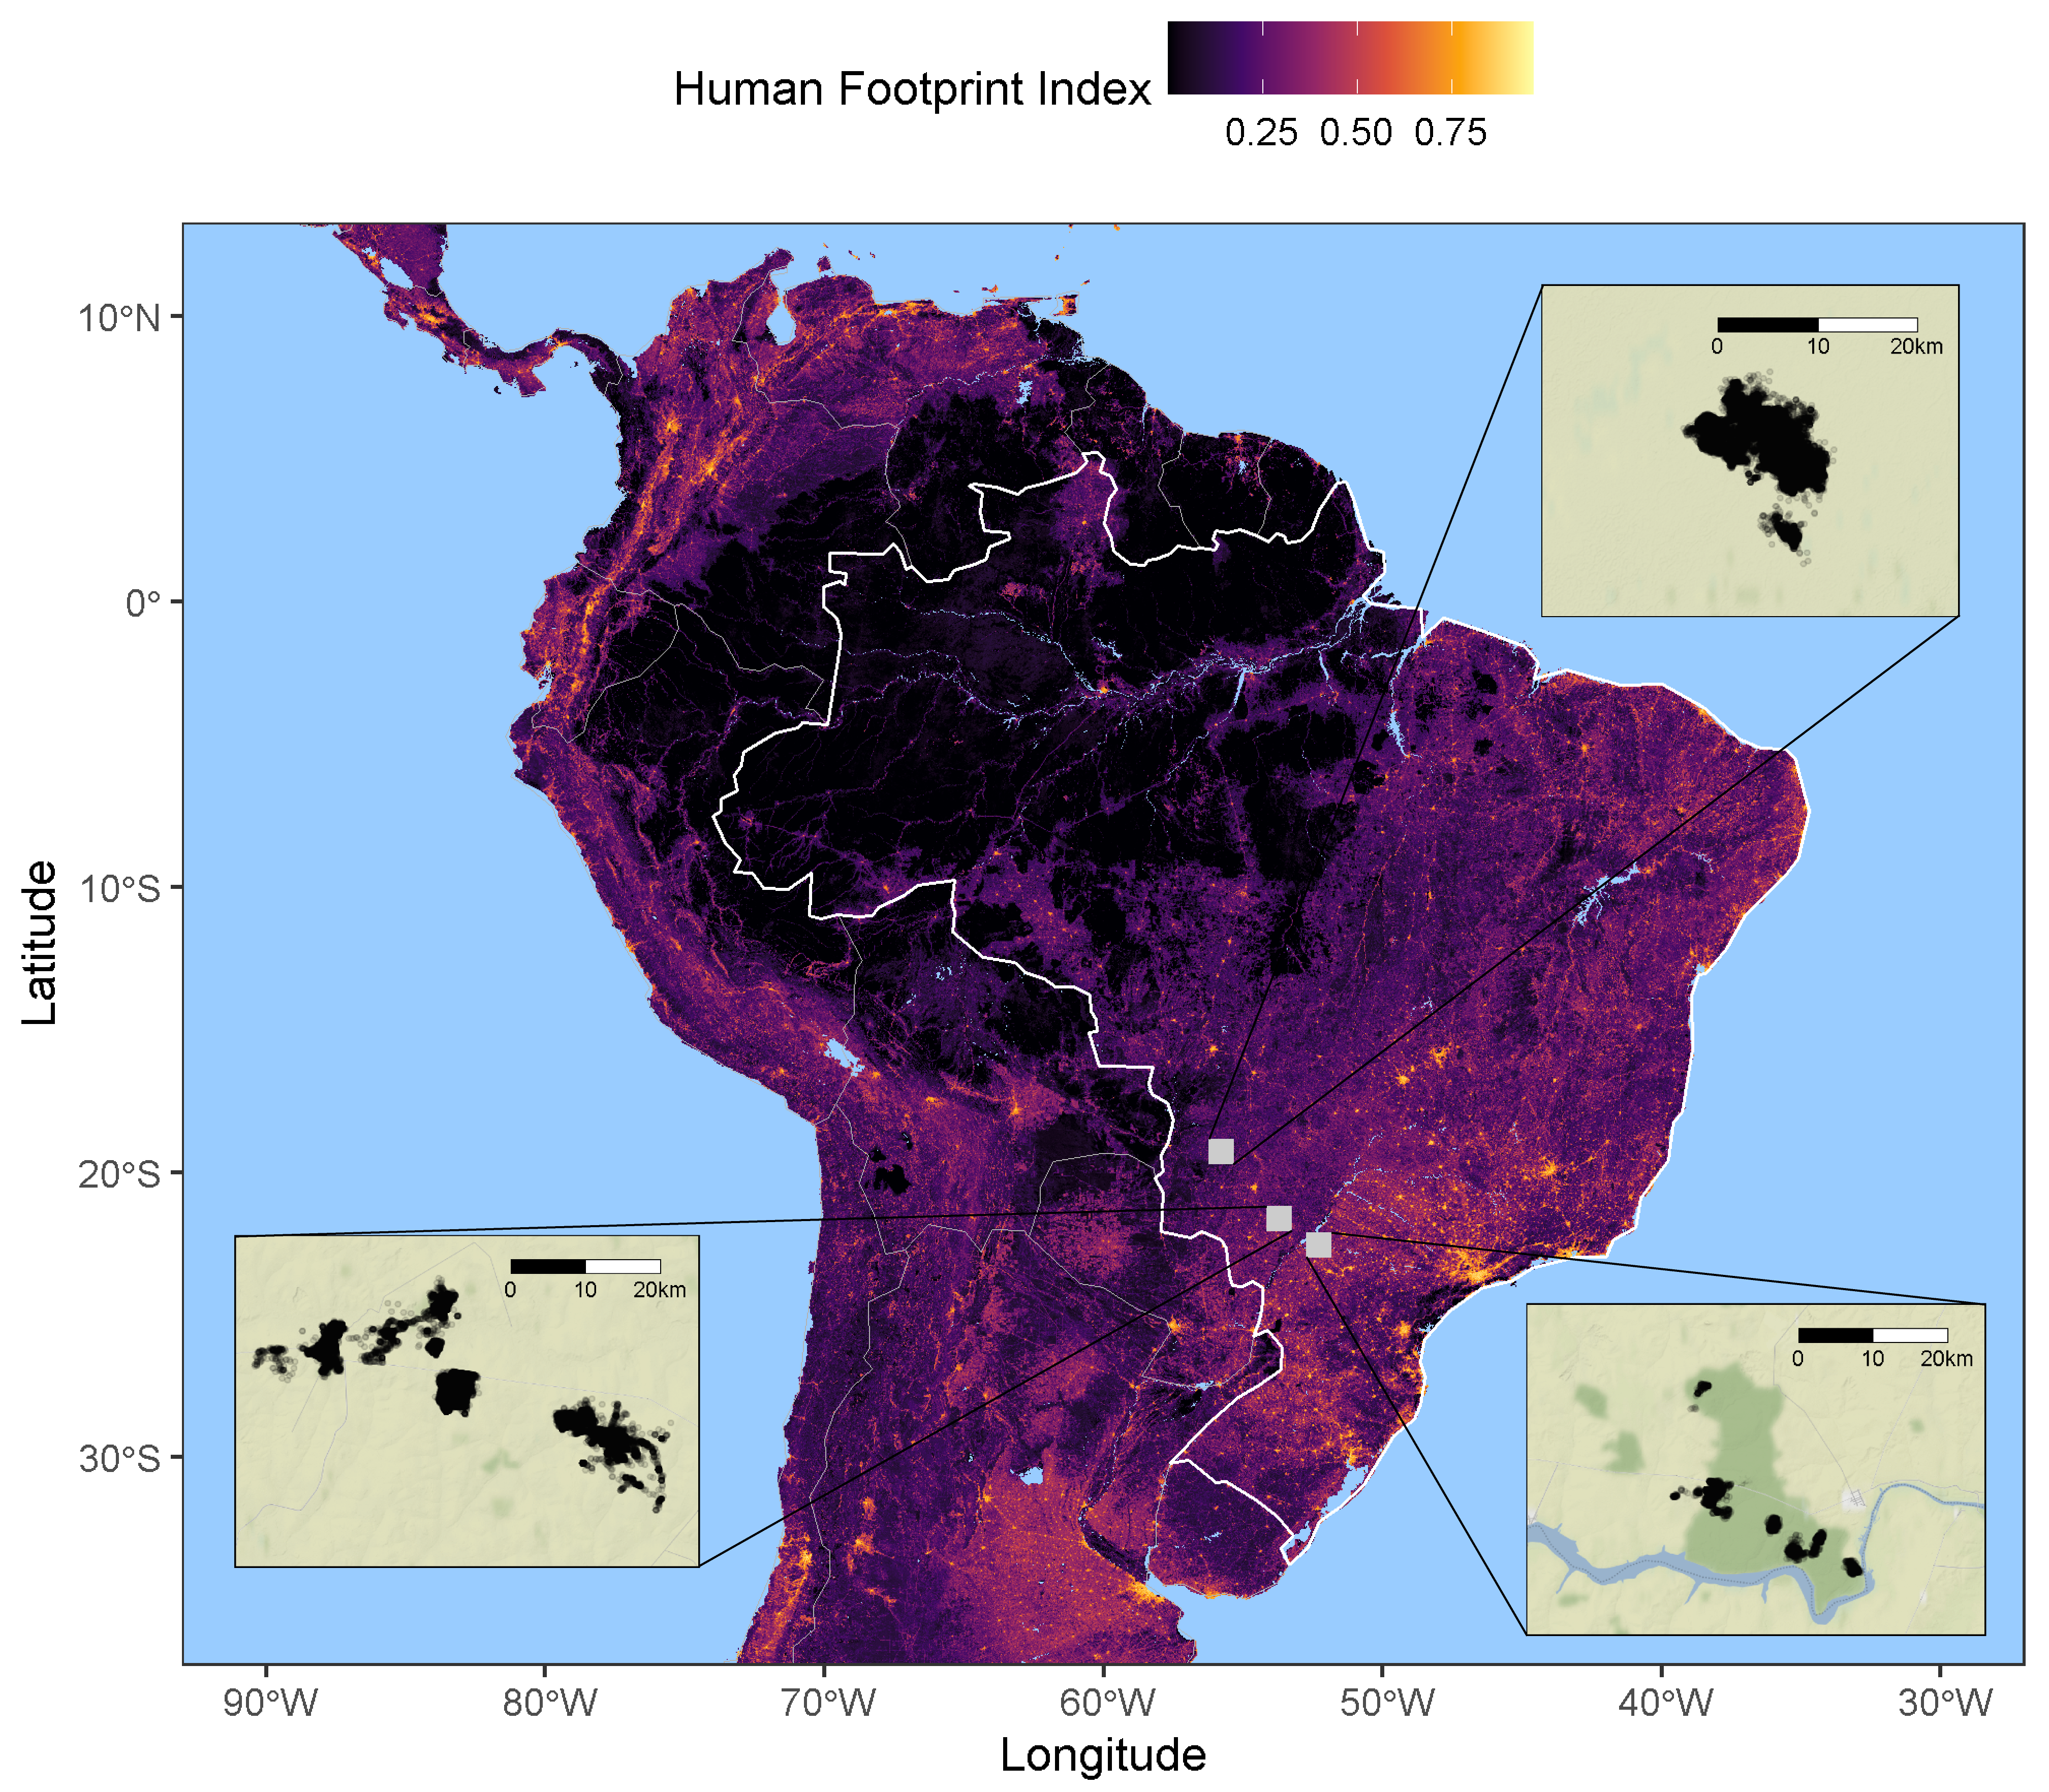

Figure 3.1: Location of the tree study sites (Pantanal, Cerrado, Mata Atlântica) over a raster of machine machine-learning-based human footprint index (ml-HFI), an index of human pressure on the landscape that is derived from remotely sensed surface imagery and ranges on a scale between 0 (no human impact), and 1 (high human impact). [THIS IS LOOKING GOOD, BUT THERE ARE A FEW MORE CHANGES TO MAKE. PLEASE ENLARGE THE AXIS LABEL/TITLE TEXT A BIT. CAN YOU MAKE SURE THE COLOURS OF THE TRACKING DATA MATCH THOSE IN THE HR FIG BELOW. ON THE FULL MAP CAN YOU CHANGE FROM FILLED BOXES TO EMPTY BOXES SO WE CAN SEE THE UNDERLYING HFI. ALSO, CAN YOU SWITCH TO A MUCH DARKER BLUE SO THAT I CAN USE WHITE LINES INSTEAD OF BLACK TO CONNECT THE INSETS. LAST, CAN YOU MAKE SURE 0 AND 1 ARE ON THE HFI SCALE BAR, AND CHANGE THE TITLE OF THE SCALE BAR TO ml-HFI]

## 3.2 Data analysis

All statistical analysis and plotting were performed using R (version 4.0.5, R Core Team 2021) using packages ctmm (version 0.6.1, “Ctmm: Continuous-Time Movement Modeling,” n.d.), mgcv (version 1.8-36, Wood 2017), ggplot2 (version , Wickham 2016) ggmap (version , Kahle and Wickham 2013). The furrr package (version 0.2.2, Vaughan and Dancho 2021) was used for parallel computation on Windows machines. All R code can be found in the GitHub repository at <https://github.com/StefanoMezzini/tapirs>.

### 3.2.1 Data calibration and cleaning

Before analysis, we performed an error calibration and data cleaning process in order to minimise the impacts of GPS measurement error and outliers on our subsequent analyses (C. H. Fleming et al. 2020). Data cleaning and calibration were carried out using the methods methods implemented in the ctmm R package (“Ctmm: Continuous-Time Movement Modeling,” n.d.). For this process, location estimates collected via VHF telemetry were assumed to be free from any meaningful measurement error and raw, uncalibrated locations were carried forward in the analyses. Location estimates collected via GPS tracking were calibrated using a unitless Horizontal Dilution of Precision (HDOP), which estimated the accuracy of each positional fix. We then estimated an equivalent range error with the HDOP values from 883 and 174 measurements from tags in fixed locations in the Pantanal and Cerrado, respectively. This allowed for the unite-less HDOP values to be converted into estimates of measurement error in meters. After calibration, data points were considered as outliers (and removed) if they had a large (error-informed) distance from the median location and the minimum speed required to explain the displacement was unusually high ($≥1$ m/s). The Mata Atlântica dataset contained a total of 4 082 observations, 8 of which were removed as outliers; the Pantanal dataset contained 139 138 observations, 914 of which were removed; while the Cerrado dataset contained 90 402 observations, 193 of which were removed. *(no speed outliers found when I (Stefano) was cleaning the datasets, but 1105 outliers had already been removed)*

### 3.2.2 Movement modelling and home range estimation

For each of the monitored tapirs we quantified a number of key movement metrics and home range related characteristics that allowed us to test for an effect of human disturbance on tapir movement behaviour. For this we first identified the best Continuous-Time Movement Model (CTMM) for each animal using the ctmm.select function from the ctmm package. This fits a series of CTMMs to location data using perturbative Hybrid Residual Maximum Likelihood (pHREML, Christen H. Fleming et al. (2019)) and chooses the best model using small-sample-sized corrected Akaike’s Information Criterion (AICc). The models used here are insensitive to sampling frequency (Michael J. Noonan et al. (2019)) and they account for spatio-temporal autocorrelation in the data (when necessary), so they are robust to irregular or frequent sampling frequency (C. H. Fleming et al. 2018), HR underestimation (M. J. Noonan et al. 2019), and significance inflation [META PAPER IN PREP WHICH WE CAN CITE WHEN IT’S ON THE ARCHIVE]. The parameter estimates from each individual’s movement model provided information on the tapir’s home range crossing time (in days), and directional persistence timescale (in hours).

We then conditioned off of the selected CTMMs to estimated each animal’s 95% home range (HR) area (in km $​^{2}$) using small-sample-size bias corrected Autocorrelated Kernel Density Estimation (AKDE) (Christen H. Fleming and Calabrese 2017), and average daily speed (in km/day) using continuous-time speed and distance (CTSD) estimation (Michael J. Noonan et al. 2019).

### 3.2.3 Movement pattern analyses

We were first interested in understanding how home-range areas and movement metrics differed across the three biomes, as well as between animals of different age and sex. For these comparisons, home range estimates were compared using the meta-analysis methods implemented in the ctmm package [CITE META PAPER], whereas other movement metrics were analysed using the meta-regression model implemented in the R package metafor (Viechtbauer 2010), which allowed uncertainty in each individual estimate to be propagated into the population level estimate when making comparisons.

To test whether environmental modification significantly altered the animals’ behavior, the HR sizes and average daily speeds were regressed against their HR’s average machine machine-learning-based human footprint index (ml-HFI) (Keys, Barnes, and Carter 2021). The ml-HFI is an index of human pressure on the landscape that is derived from remotely sensed surface imagery and ranges on a scale between 0 (no human impact), and 1 (high human impact). For these models we applied Generalized Linear Models (GLMs) with a Gamma distribution and a log link for the response. The Gamma distribution allows for more accurate significance testing, while the log link scale allows HFI to have a multiplicative effect on the response. The GLMs were fit using the mgcv package (Wood 2017), and Restricted Maximum Likelihood (REML).

# 4 Results

## 4.1 Individual variation in movement and space use

*change values to more appropriate estimates; currently using mean +/- 1.96 sd/sqrt(n)*

The mean home range size across all monitored tapirs was 5.82 km $​^{2}$ (95% CI: 4.71 - 7.12), ranging between 1 km $​^{2}$ and 29.7 km $​^{2}$ (Fig. 4.1a). Tapirs had HR crossing times of 0.72 days on average (95% CI: 0.35 - 1.10), ranging from 0.05 to 12.8 days (Fig. 4.1b), and a mean velocity autocorrelation timescale of 0.44 hours (95% CI: 0.39 - 0.49), ranging from 0.17 to 1.88 hours (Fig. 4.1c). We estimated that tapirs had mean movement speeds of 11.2 km/day (95% CI: 10.2 - 12.1), ranging from 1.51 to 25.96 km/day (Fig. 4.1d). There was no evidence that average daily speed differed between sexes (females: 10.5 km/day, 95% CI: 9.19 - 12.0; males: 11.9 km/day; 95% CI: 10.3 - 13.7, $p=0.22$, 4.2a), and there was little to no evidence of it differing between age groups (adults: 11.8 km/day, 95% CI: 10.6 - 13.2; sub-adults: 9.52 km/day, 95% CI: 7.94 - 11.4; $p=0.053$, Fig. 4.2b).

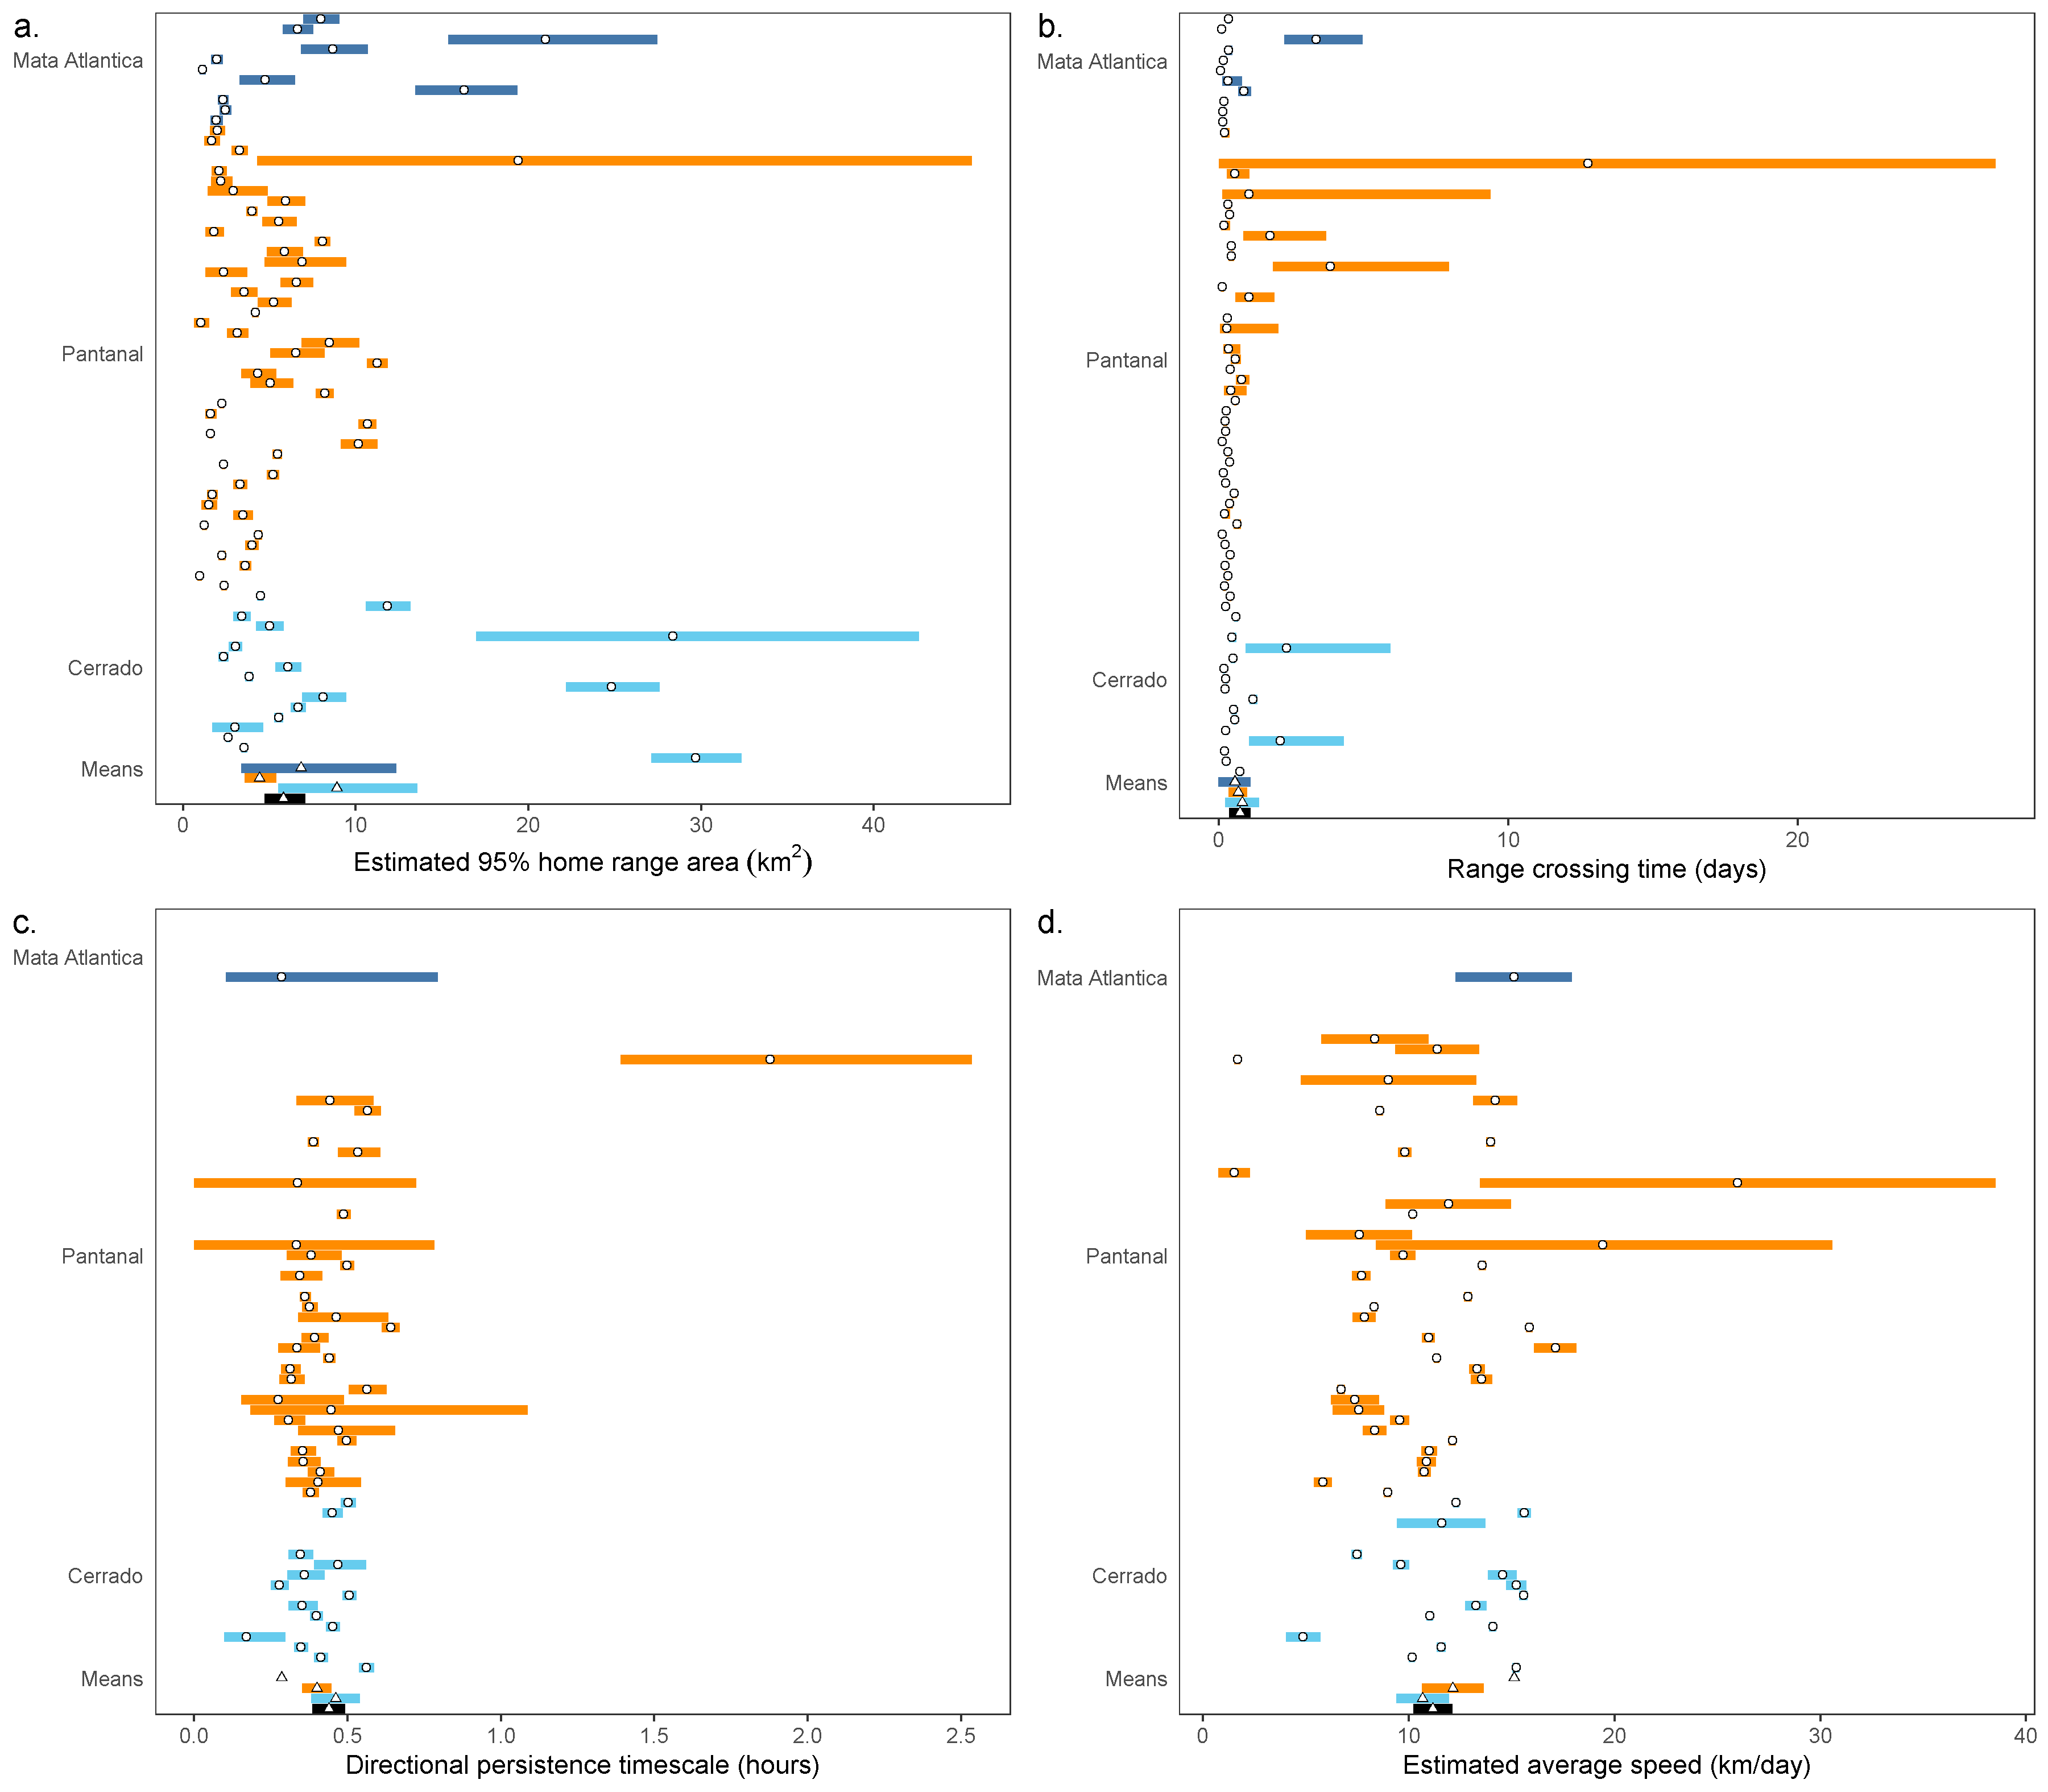

Figure 4.1: Parameter estimates from each tapir’s movement model (circles) and group means (triangles), with 95% confidence intervals. Individuals with a movement model that does not allow for inferences in movement speed are left blank. CAN YOU ENLARGE THE AXIS TEXT HER AS WELL. ALSO, CAN YOU TRY ROTATING THE STUDY SITE LABELS BY 90 DEGREES SO THEY DONT EAT UP AS MUCH SPAPCE

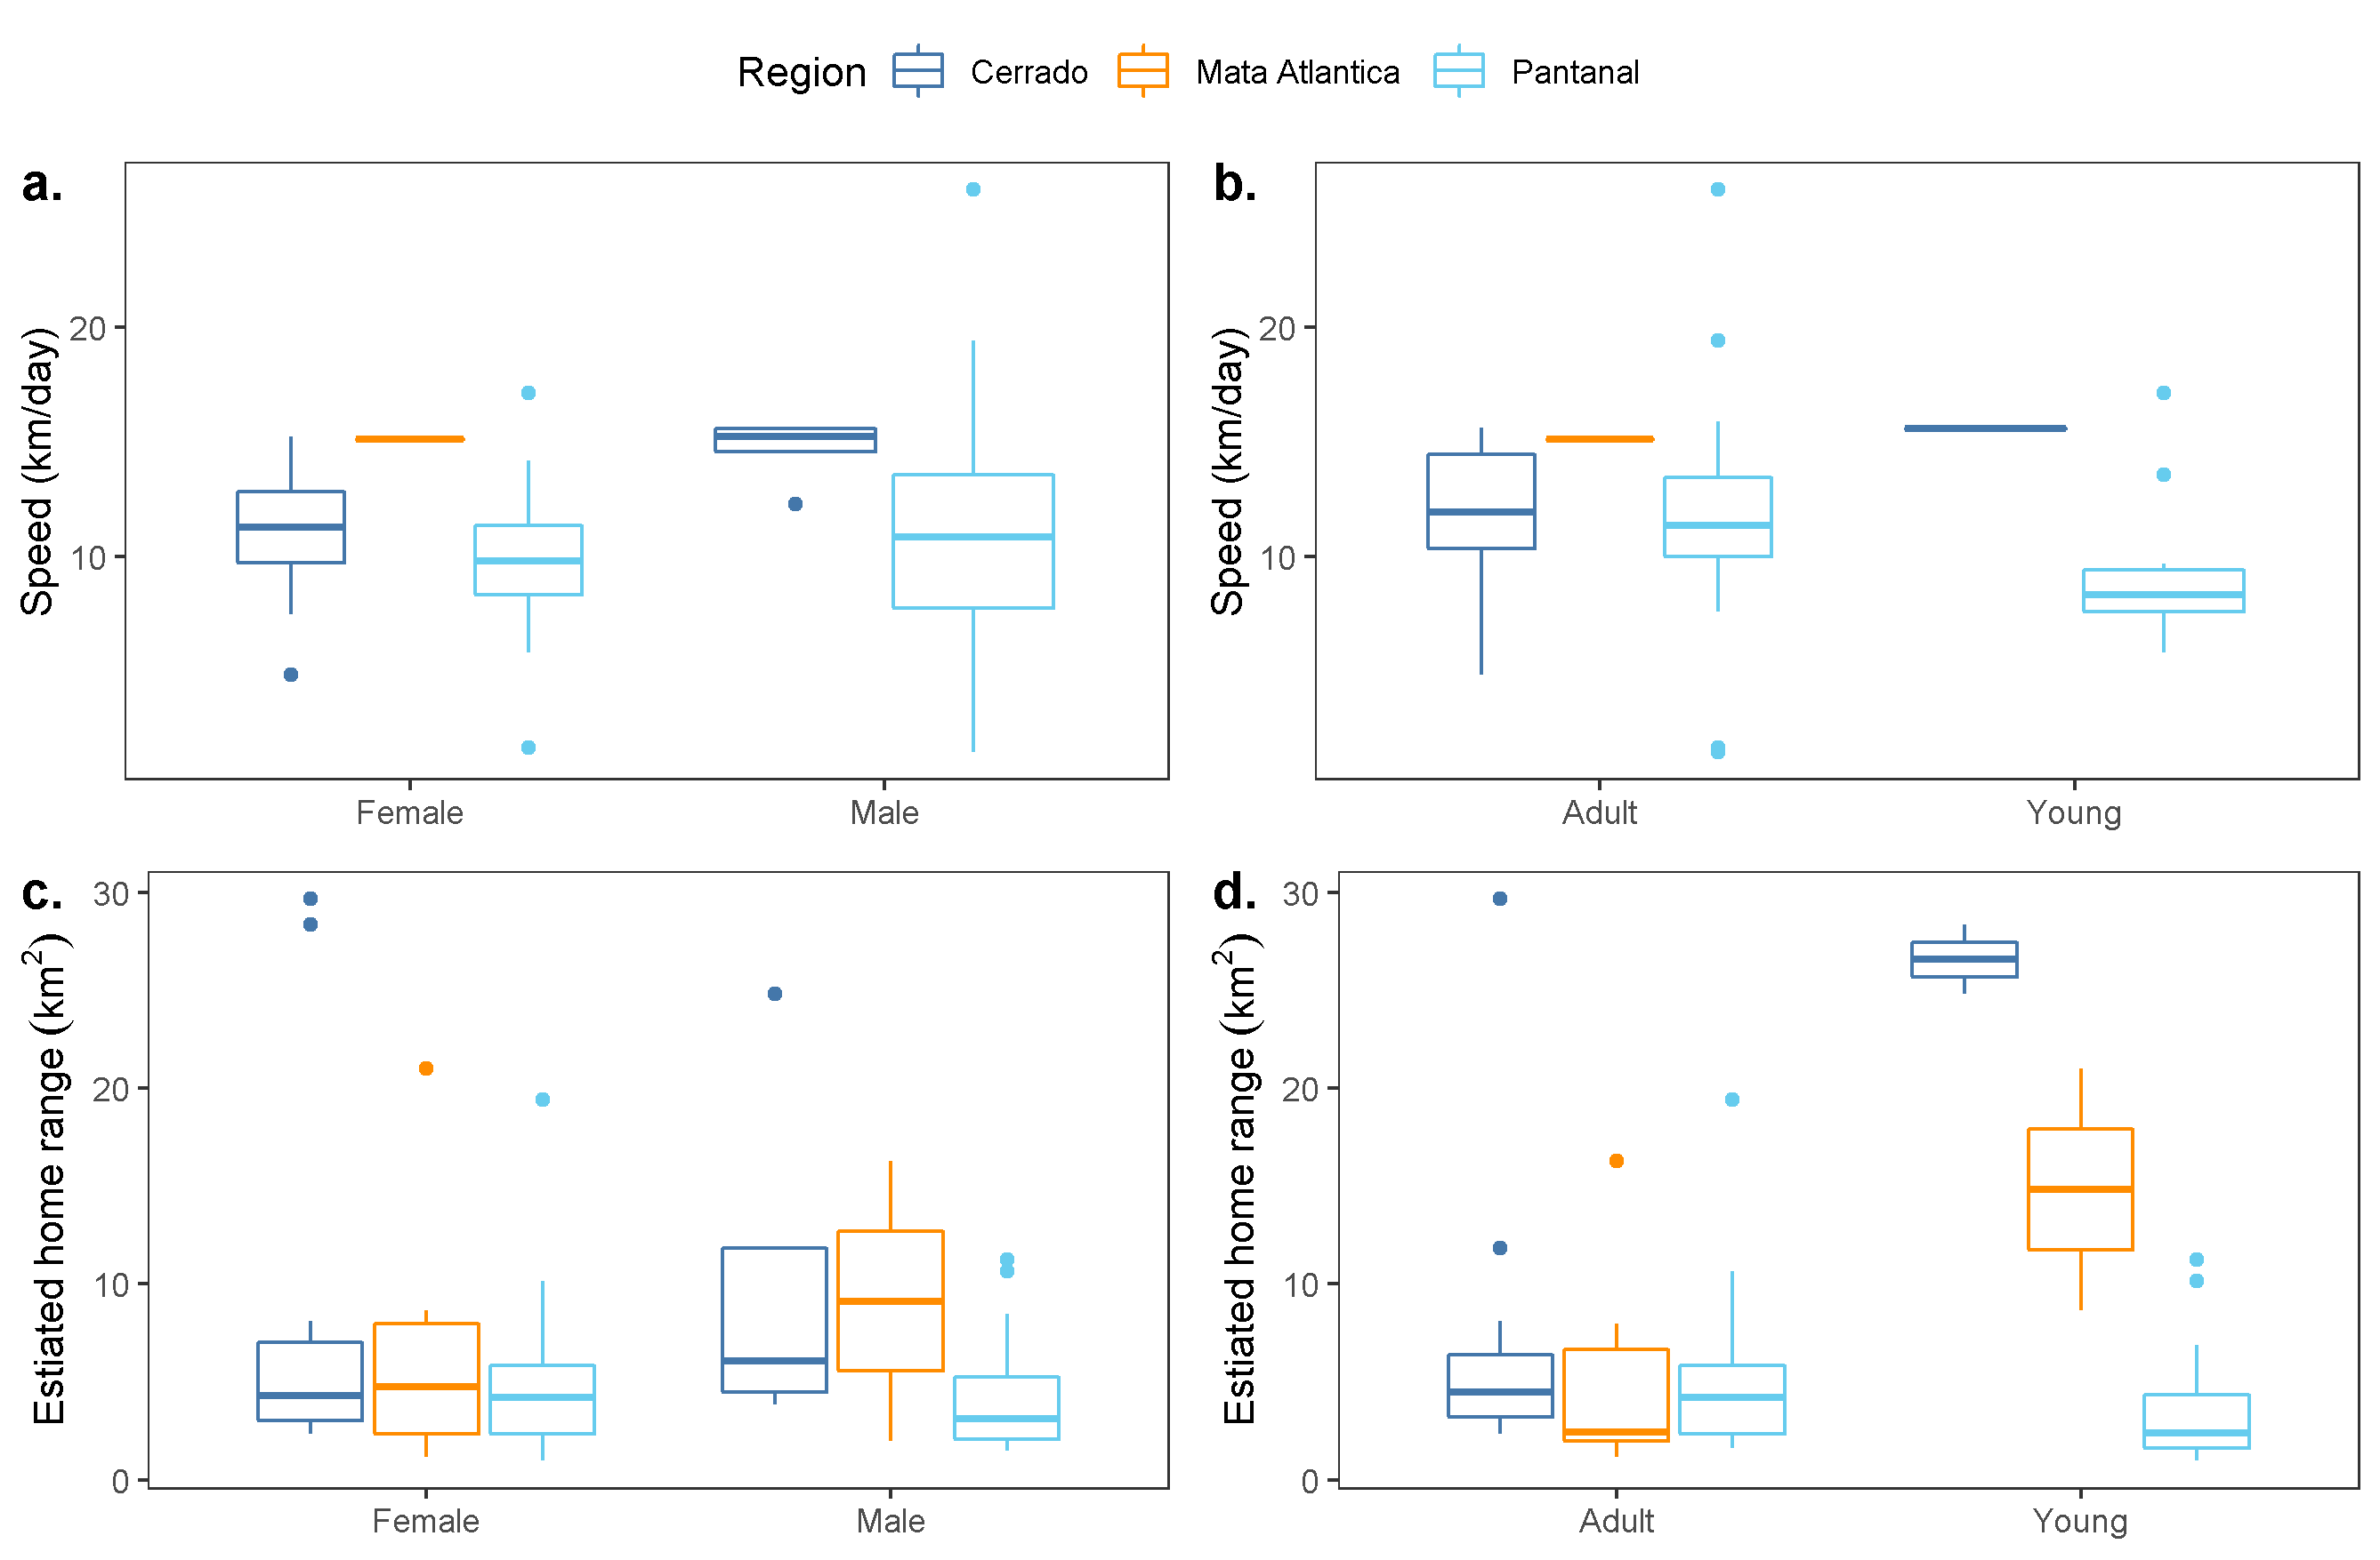

Figure 4.2: Boxplots of daily average speed (a, b) and estimated home range size (c, d) by sex and age group. [THE COLOURS NEED TO LINE UP WITH THE PREVIOUS FIGURE. ALSO, CAN YOU CHANGE THIS BLACK LINES AND A CLOLOURED FILL INSTEAD OF COLOURING THE LINES WITH AN EMPTY FILL. LARGER TEXT HERE AS WELL]

There was no evidence that home ranges sizes differed between sexes (males: 5.43 km $​^{2}$, 95% CI: 3.84 - 7.68; females: 6.27 km $​^{2}$, 95% CI: 4.64 - 8.48; $p=0.541$, Fig. 4.2c) nor between age groups (adults: 5.47 km $​^{2}$, 95% CI: 4.21 - 7.1; sub-adults: 7.01 km $​^{2}$, 95% CI: 4.63 - 10.6; $p=0.324$, Fig. 4.2d).

## 4.2 Variation in movement across biomes and gradients of human disturbance

The Atlantic Forest, Cerrado, and Pantanal varied substantially in habitat composition, levels of human disturbance, and tapir population densities (*PATI, IS THERE A SOURCE TO SUPPORT THIS STATEMENT?*). Despite this, we found that lowland tapir movement behaviour and space use were consistent across all three biomes (Fig. 4.1.

We also found [no] relationship between home range area and HABITAT LAYER RESULTS (Fig. XXX). Similar trends were observed across all other movement parameters (Fig. XXX).  
HFI had no significant effect on either lowland tapir home range size (p-value = 0.90; Fig. XXXa), nor average daily movement speed (p-value = 0.53; Fig. XXXb). A tapir living in a near pristine environment (HFI = 0.004) was estimated to have a home range of 7.77 km $​^{2}$ (95% CI: 2.12 - 28.6) and an average speed of 13.19 km/day (95% CI: 7.82 - 22.1), while a tapir from the most altered habitat we monitored (HFI = 0.31) had an estimated home range area of 6.93 km $​^{2}$ (95% CI: 3.36 - 14.3) and an average speed of 10.43 km/day (95% CI: 8.27 - 13.2).

akde figure: (Fig. 4.3)

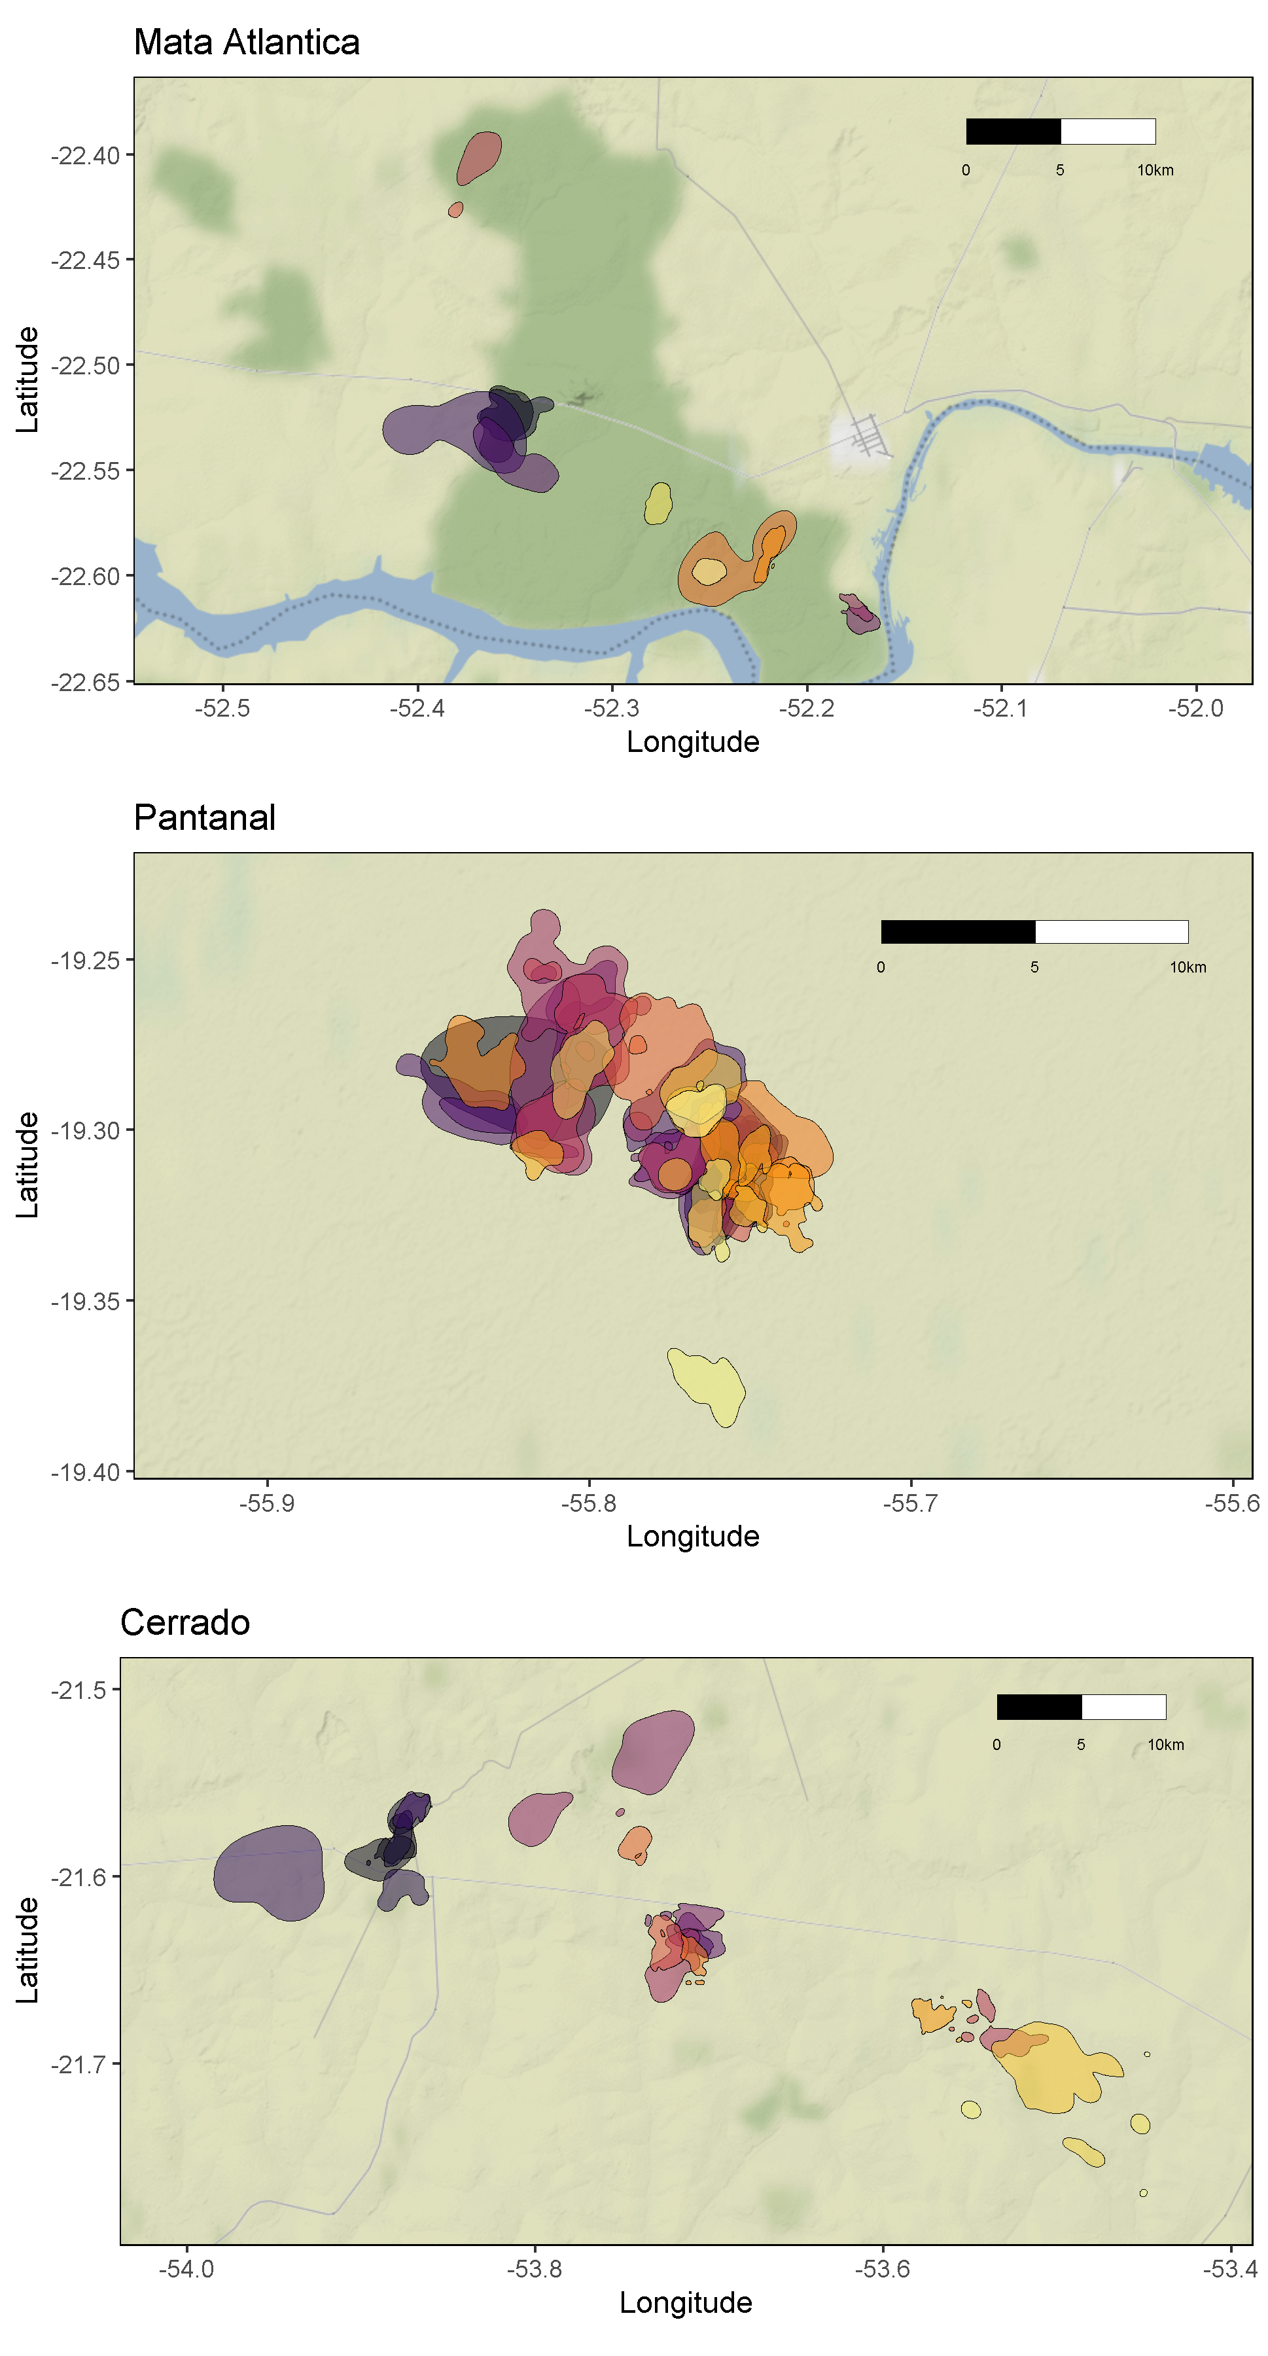

Figure 4.3: Autocorrelated kernel density estimations of each tapir’s 95% home range. THESE LOOK GOOD, BUT I THINK WE’RE GOING TO WANT BETTER UNDERLYING MAPS. WE SHOULD BE ABLE TO USE THE HABITAT LAYER RASTERS AFTER WE GET THOSE. ALSO, SAME THING ABOUT LARGER TEXT ON THE AXES.

# 5 Discussion

# 6 Acknowledgments

# References

Allen, Andrew M, and Navinder J Singh. 2016. “Linking Movement Ecology with Wildlife Management and Conservation.” *Frontiers in Ecology and Evolution* 3: 155.

Bauer, Silke, and Bethany J Hoye. 2014. “Migratory Animals Couple Biodiversity and Ecosystem Functioning Worldwide.” *Science* 344 (6179): 1242552.

Brooks, Thomas M, Russell A Mittermeier, Cristina G Mittermeier, Gustavo AB Da Fonseca, Anthony B Rylands, William R Konstant, Penny Flick, et al. 2002. “Habitat Loss and Extinction in the Hotspots of Biodiversity.” *Conservation Biology* 16 (4): 909–23.

Cardinale, Bradley J, J Emmett Duffy, Andrew Gonzalez, David U Hooper, Charles Perrings, Patrick Venail, Anita Narwani, et al. 2012. “Biodiversity Loss and Its Impact on Humanity.” *Nature* 486 (7401): 59–67.

Cosgrove, Anita J, Todd J McWhorter, and Martine Maron. 2018. “Consequences of Impediments to Animal Movements at Different Scales: A Conceptual Framework and Review.” *Diversity and Distributions* 24 (4): 448–59.

“Ctmm: Continuous-Time Movement Modeling.” n.d. <https://github.com/ctmm-initiative/ctmm, https://groups.google.com/g/ctmm-user>.

Dickie, Melanie, Robert Serrouya, R Scott McNay, and Stan Boutin. 2017. “Faster and Farther: Wolf Movement on Linear Features and Implications for Hunting Behaviour.” *Journal of Applied Ecology* 54 (1): 253–63.

Doherty, Tim S, Graeme C Hays, and Don A Driscoll. 2021. “Human Disturbance Causes Widespread Disruption of Animal Movement.” *Nature Ecology & Evolution* 5 (4): 513–19.

Esfahani, Hadi Salehi, and Marı́a Teresa Ramı́rez. 2003. “Institutions, Infrastructure, and Economic Growth.” *Journal of Development Economics* 70 (2): 443–77.

Fahrig, Lenore. 1997. “Relative Effects of Habitat Loss and Fragmentation on Population Extinction.” *The Journal of Wildlife Management*, 603–10.

———. 2007. “Non-optimal animal movement in human-altered landscapes.” *Functional Ecology* 21 (6): 1003–15.

Fleming, C. H., J. Drescher-Lehman, M. J. Noonan, T. S. B. Akre, D. J. Brown, M. M. Cochrane, N. Dejid, et al. 2020. “A Comprehensive Framework for Handling Location Error in Animal Tracking Data*.” Preprint. Ecology. <https://doi.org/10.1101/2020.06.12.130195>.

Fleming, C. H., M. J. Noonan, E Patricia Medici, and J. M. Calabrese. 2019. “Overcoming the Challenge of Small Effective Sample Sizes in Home-Range Estimation.” *Methods in Ecology and Evolution* 10 (10): 1679–89.

Fleming, C H, D Sheldon, W F Fagan, P Leimgruber, T Mueller, D Nandintsetseg, M J Noonan, et al. 2018. “Correcting for missing and irregular data in home-range estimation.” *Ecological Applications* 28 (4): 1003–10.

Fleming, Christen H., Michael J. Noonan, Emilia Patricia Medici, and Justin M. Calabrese. 2019. “Overcoming the Challenge of Small Effective Sample Sizes in Home‐range Estimation.” Edited by Jason Matthiopoulos. *Methods in Ecology and Evolution* 10 (10): 1679–89. <https://doi.org/10.1111/2041-210X.13270>.

Fleming, Christen H, and Justin M Calabrese. 2017. “A new kernel density estimator for accurate home-range and species-range area estimation.” *Methods in Ecology and Evolution* 8 (5): 571–79.

He, Peng, Pierre-Olivier Montiglio, Marius Somveille, Mauricio Cantor, and Damien R. Farine. 2021. “The Role of Habitat Configuration in Shaping Animal Population Processes: A Framework to Generate Quantitative Predictions.” *Oecologia*. <https://doi.org/10.1007/s00442-021-04967-y>.

Hooper, David U, E Carol Adair, Bradley J Cardinale, Jarrett EK Byrnes, Bruce A Hungate, Kristin L Matulich, Andrew Gonzalez, J Emmett Duffy, Lars Gamfeldt, and Mary I O’Connor. 2012. “A Global Synthesis Reveals Biodiversity Loss as a Major Driver of Ecosystem Change.” *Nature* 486 (7401): 105–8.

Kahle, David, and Hadley Wickham. 2013. “Ggmap: Spatial Visualization with Ggplot2.” *The R Journal* 5 (1): 144. <https://doi.org/10.32614/RJ-2013-014>.

Keys, Patrick W, Elizabeth A Barnes, and Neil H Carter. 2021. “A Machine-Learning Approach to Human Footprint Index Estimation with Applications to Sustainable Development.” *Environmental Research Letters* 16 (4): 044061.

Martinez-Garcia, Ricardo, Christen H Fleming, Ralf Seppelt, William F Fagan, and Justin M Calabrese. 2020. “How Range Residency and Long-Range Perception Change Encounter Rates.” *Journal of Theoretical Biology*, 110267.

Morato, Ronaldo G, Jared A Stabach, Chris H Fleming, Justin M Calabrese, Rogerio C de Paula, Kátia M P M Ferraz, Daniel L Z Kantek, et al. 2016. “Space Use and Movement of a Neotropical Top Predator: The Endangered Jaguar.” *PLoS ONE* 11 (12): e0168176.

Myers, P, R Espinosa, CS Parr, T Jones, GS Hammond, and TA Dewey. 2006. “The Animal Diversity Web. University of Michigan.” *Ann Arbor. Available from Http://Animaldiversity. Ummz. Umich. Edu/Site/Index. Html (Accessed May 2010)*.

Noonan, M. J., Ma. A. Tucker, C. H. Fleming, S. C. Alberts, A. H. Ali, J. Altmann, P. C. Antunes, et al. 2019. “A Comprehensive Analysis of Autocorrelation and Bias in Home Range Estimation.” *Ecological Monographs* 89 (2): e01344.

Noonan, Michael J., Christen H. Fleming, Thomas S. Akre, Jonathan Drescher-Lehman, Eliezer Gurarie, Autumn-Lynn Harrison, Roland Kays, and Justin M. Calabrese. 2019. “Scale-Insensitive Estimation of Speed and Distance Traveled from Animal Tracking Data.” *Movement Ecology* 7 (1): 35. <https://doi.org/10.1186/s40462-019-0177-1>.

Powers, Ryan P, and Walter Jetz. 2019. “Global Habitat Loss and Extinction Risk of Terrestrial Vertebrates Under Future Land-Use-Change Scenarios.” *Nature Climate Change* 9 (4): 323–29.

R Core Team. 2021. *R: A Language and Environment for Statistical Computing*. Vienna, Austria: R Foundation for Statistical Computing. <https://www.R-project.org/>.

Schick, Robert S, Scott R Loarie, Fernando Colchero, Benjamin D Best, Andre Boustany, Dalia A Conde, Patrick N Halpin, Lucas N Joppa, Catherine M McClellan, and James S Clark. 2008. “Understanding movement data and movement processes: Current and emerging directions.” *Ecology Letters* 11 (12): 1338–50.

Thatte, Prachi, Anuradha Chandramouli, Abhinav Tyagi, Kaushal Patel, Phulmani Baro, Himanshu Chhattani, and Uma Ramakrishnan. 2020. “Human Footprint Differentially Impacts Genetic Connectivity of Four Wide-Ranging Mammals in a Fragmented Landscape.” *Diversity and Distributions* 26 (3): 299–314.

Toews, Mary, Francis Juanes, and A Cole Burton. 2018. “Mammal Responses to the Human Footprint Vary Across Species and Stressors.” *Journal of Environmental Management* 217: 690–99.

Tucker, Marlee A, Katrin Böhning-Gaese, William F Fagan, John M Fryxell, Bram Van Moorter, Susan C Alberts, Abdullahi H Ali, et al. 2018. “Moving in the Anthropocene: Global reductions in terrestrial mammalian movements.” *Science* 359 (6374): 466–69.

Tucker, Marlee A, Michela Busana, Mark AJ Huijbregts, and Adam T Ford. 2021. “Human-Induced Reduction in Mammalian Movements Impacts Seed Dispersal in the Tropics.” *Ecography*.

Varela, D, K Flesher, JL Cartes, S De Bustos, S Chalukian, G Ayala, and C Richard-Hansen. 2019. “Tapirus Terrestris.” *The IUCN Red List of Threatened Species*, 2020–21.

Vaughan, Davis, and Matt Dancho. 2021. “Furrr: Apply Mapping Functions in Parallel Using Futures.” <https://CRAN.R-project.org/package=furrr>.

Venter, Oscar, Oscar Venter, Nathalie N Brodeur, Nathalie N Brodeur, Leah Nemiroff, Leah Nemiroff, Brenna Belland, et al. 2006. “Threats to Endangered Species in Canada.” *BioScience* 56 (11): 903–10.

Viechtbauer, Wolfgang. 2010. “Conducting Meta-Analyses in r with the Metafor Package.” *Journal of Statistical Software* 36 (3): 1–48.

Wall, Jake, George Wittemyer, Brian Klinkenberg, Valerie LeMay, Stephen Blake, Samantha Strindberg, Michelle Henley, et al. 2021. “Human Footprint and Protected Areas Shape Elephant Range Across Africa.” *Current Biology* 31 (11): 2437–45.

Wickham, Hadley. 2016. *Ggplot2: Elegant Graphics for Data Analysis*. Springer-Verlag New York. <https://ggplot2.tidyverse.org>.

Wood, S. N. 2017. *Generalized Additive Models: An Introduction with R*. 2nd ed. Chapman; Hall/CRC.